- Battery safety terminal (BST);
2. Line to B+ junction, starter and alternator;
3. Line to engine electronics;
4. Line to IBS electronics;
5. Line to junction box;
6. Battery sensor (IBS);
7. Battery ground cable;
8. High amperage fuses (fusible links);
9. Housing;
10. High current connector; 11. Battery.

Rear Power Distribution.

Rear power distribution panel
№ | A | Protected circuits
 |  | before 03.2007:
F104 |  | Intelligent battery sensor (IBS)
F105 | 100 | Electronic power steering
F106 | 100 | Auxiliary heater
F106 | 100 | Electric auxiliary heater
F108 | 250 | Junction box
F203 | 100 | B+ terminal (engine compartment)
— |  | Starter, battery
 |  | since 03.2007:
F101 | 250 | Junction box
F102 | 100 | B+ terminal (engine compartment), starter, battery
F103 | 100 | Electronic power steering
F104 | 100 | Auxiliary heater
F105 |  | Intelligent battery sensor (IBS)
F106 | 100 | Electric auxiliary heater

Glove Box Fuses

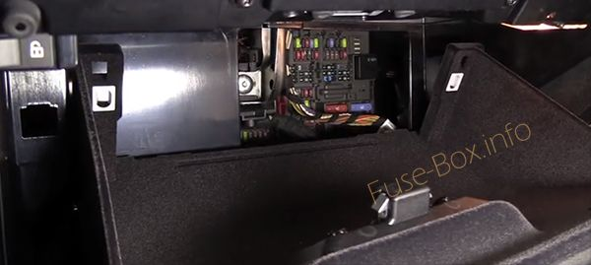

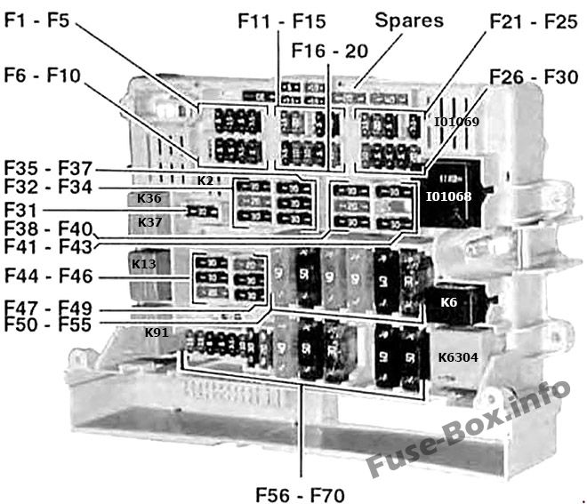
Assignment of the fuses in the glove compartment (type 1, before 03.2007)
№ | A | Protected circuits
F1 | — | Not used
F2 | 5 | Diversity antenna
F3 | 20 | Passenger seat heating
F4 | 5 | Car access system
F5 | 7.5 | Roof function control center
F6 | 15 | Transmission control module
F7 | 20 | Auxiliary heater control module
F8 | 5 | CD changer  Diversity antenna
F9 | 10 | Active cruise control
F10 | — | Not used
F11 | 10 | Radio
F12 | 20 | Convertible top or sunroof control  Roof function center (FZD)
F13 | 5 | iDrive controller
F14 | — | Not used
F15 | 5 | AUC sensor
F16 | 15 | Horns
F17 | 5 | Telephone eject box  Telephone transceiver
F18 | 5 | CD changer
F19 | 7.5 | Comfort access control module  Front door outer handles control modules  Siren and tilt alarm sensor
F20 | 5 | DSC  Transfer case control module
F21 | 7.5 | Driver door switch cluster  Outside rear view mirrors
F22 | 10 | Longitudinal dynamics management  Towing hitch release speaker
F23 | 10 | Digital tuner  Satellite radio
F24 | 5 | Tire pressure control (RDC)
F25 | 10 | Front seat belts positioner control modules
F26 | 10 | Shift selector lighting  Telephone eject box  Telephone transceiver
F27 | 5 | Driver door switch cluster  Telephone transceiver
F28 | 5 | Roof function control center  Park distance control (PDC)
F29 | 5 | AUC sensor  Front seat heating modules
F30 | 20 | 12-volt utility sockets  Front cigar lighter
F31 | 20 | CCC/M-ASK  Radio
F32 | 30 | Driver seat heating module  Driver seat module
F33 | 30 | Front seat control
F34 | 30 | Sound system amplifier
F35 | 30 | DSC
F36 | 30 | Footwell module
F37 | 30 | Driver seat control
F38 | 30 | Transfer case control module
F39 | 30 | Wipers
F40 | 20 | Fuel pump (EKPS)
F41 | 30 | Footwell module
F42 | 30 | Trailer module
F43 | 30 | Headlight washer pump
F44 | 30 | Trailer module
F45 | 40 | Active steering
F46 | 30 | Rear window defroster
F47 | 20 | Trailer socket
F48 | 20 | Rear wiper and washer control
F49 | 30 | Passenger seat heating
F50 | 40 | Active steering
F51 | 50 | Car access system
F52 | 50 | Footwell module
F53 | 50 | Footwell module
F54 | 60 | B+ potential distributor
F55 | — | Not used
F56 | 15 | Central locking
F57 | 15 | Central locking
F58 | 5 | Instrument cluster  OBD II socket
F59 | 5 | Steering column switch cluster
F60 | 7.5 | A/C and heating system
F61 | 10 | Cargo compartment lights  Central information display  Glove compartment light  Trunk light
F62 | 30 | Window control
F63 | 30 | Window control
F64 | 30 | Window control
F65 | 40 | DSC
F66 | 50 | Fuel heater (Diesel)
F67 | 50 | Blower output stage
F68 | 50 | Vacuum pump relay
F69 | 50 | Engine cooling fan
F70 | 50 | Secondary air injection pump
F71 | 20 | Trailer socket
F72 | — | Not used
F73 | — | Not used
F74 | — | Not used
F75 | — | Not used
F76 | — | Not used
F77 | 30 | Fuel injectors  Ignition coils  Interference suppression capacitor
F78 | — | Not used
F79 | — | Not used
F80 | — | Not used
F81 | — | Not used
F82 | — | Not used
F83 | — | Not used
F84 | — | Not used
F85 | — | Not used
F86 | — | Not used
F87 | — | Not used
F88 | — | Not used
I01068 |  | Relay, terminal 30g
I01069 |  | Relay, terminal 15 (on PC board)
K2 |  | Horn relay (on PC board)
K6 |  | Headlight washer relay
K13 |  | Rear window defroster relay
K36 |  | Wiper relay 1
K37 |  | Wiper relay 2
K91 |  | Rear wiper relay (Sports Wagon)
K6304 |  | Secondary air injection pump relay

Type 2 Fuse Box 2007 0n
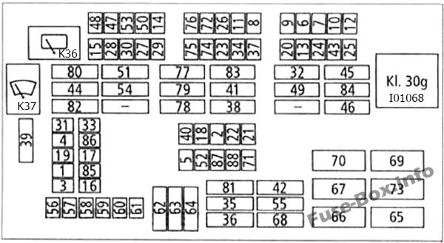

Assignment of the fuses in the glove compartment (type 2, 03.2007-09.2007)
№ | A | Protected circuits
F1 | 10 | Rollover protection control module
F2 | 5 | Instrument cluster  OBD II plug
F3 | 20 | Passenger seat heating
F4 | 5 | Car access system
F5 | — | Not used
F6 | 15 | Transmission control module
F7 | 20 | Auxiliary heater control module
F8 | 20 | Sound system amplifier
F9 | 10 | Active cruise control
F10 | 15 | Trailer module
F11 | 10 | Radio
F12 | 20 | Convertible top or sunroof control  Roof function center (FZD)
F13 | 5 | iDrive controller  Tire pressure control (RDC)
F14 | — | Not used
F15 | 5 | AUC sensor
F16 | 15 | Horns
F17 | 5 | Telephone eject box  Telephone transceiver
F18 | 5 | Convertible:  Diversity antenna  Gearshift bezel lighting  Non-convertible:  Electrochromic rear view mirror  Gearshift bezel lighting
F19 | 7.5 | Siren and tilt alarm sensor
F20 | 5 | DSC  Transfer case control module
F21 | 7.5 | Driver door switch cluster  Outside rear view mirrors
F22 | 10 | Longitudinal dynamics management
F23 | 10 | Digital tuner  Satellite radio
F24 | 5 | DC converter  Fan cutout relay
F25 | 10 | Front seat belts positioner control modules
F26 | 10 | Telephone eject box  Telephone transceiver
F27 | 5 | Driver door switch cluster  Telephone transceiver
F28 | 5 | Roof function control center  Park distance control (PDC)
F29 | 6 | Front seat heating modules
F30 | 20 | 12-volt utility sockets  Front cigar lighter
F31 | 20 | CCC/M-ASK
F32 | 30 | Driver seat module
F33 | 5 | Comfort access control module  Front door outer handles control modules
F34 | 5 | CD changer  Diversity antenna
F35 | 30 | DSC
F36 | 30 | Footwell module
F37 | 10 | Front seat control
F38 | 30 | Transfer case control module
F39 | 30 | Wipers
F40 | 7.5 | Roof function control center
F41 | 30 | Footwell module
F42 | 40 | Footwell module
F43 | — | Not used
F44 | 30 | Trailer module
F45 | 40 | Active steering
F46 | 30 | Rear window defroster
F47 | 20 | Trailer socket
F48 | 20 | Rear wiper and washer control
F49 | 30 | Passenger seat module
F50 | 10 | Engine control module (ECM)
F51 | 40 | Car access system
F52 | 20 | Driver seat heating
F53 | 20 | Passenger seat heating
F54 | 30 | Trailer module
F55 | — | Not used
F56 | 15 | Central locking
F57 | 15 | Central locking
F58 | 5 | Instrument cluster  OBD II socket
F59 | 5 | Steering column switch cluster
F60 | 5 | Central information display
F61 | 10 | Cargo compartment lights  Central information display  Glove compartment light  Trunk light
F62 | 30 | Window control
F63 | 30 | Window control
F64 | 30 | Window control
F65 | 10 | Selector lever illumination  Longitudinal dynamics management
F66 | 50 | Fuel heater (Diesel)
F67 | 40 | Blower output stage
F68 | 40 | Footwell module
F69 | 50 | 400 watt engine cooling fan
F69 | 60 | 600 watt engine cooling fan
F70 | 40 | Secondary air injection pump
F71 | 20 | Trailer socket
F72 | — | Not used
F73 | — | Not used
F74 | 10 | Engine control module (ECM)  Exhaust flap  Fuel tank leakage diagnostic module  Nitrogen oxide sensor
F75 | 10 | EAC sensor  E-box fan  ECM  Secondary air pump relay
F76 | 30 | Crankshaft sensor  Fuel tank vent valve  Mass air flow sensor  Oil condition sensor  Variable intake manifold controllers  Volume control valve
F77 | 30 | Fuel injectors  Ignition coils  Ignition coil interference suppression capacitor
F78 | 30 | Camshaft sensors  Coolant thermostat  Electric coolant pump  Engine control module (ECM)  VANOS valves  Waste gate valves
F79 | 30 | Crankcase breather heating  Oxygen sensor heating
F80 | 40 | Non-turbo: Electric coolant pump
F81 | 30 | Trailer module
F82 | — | Not used
F83 | 40 | Footwell module
F84 | 30 | Headlight washer pump
F85 | — | Not used
F86 | — | Not used
F87 | — | Not used
F88 | 20 | Fuel pump (EKPS)
I01068 |  | Relay, terminal 30g
K36 |  | Wiper relay 1
K37 |  | Wiper relay 2

Fuse box diagram (type 3, since 09.2007)
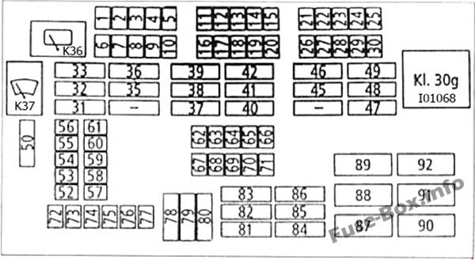
Assignment of the fuses in the glove compartment (type 3, since 09.2007)
№ | A | Protected circuits
F1 | 10 | Rear wiper and washer
F2 | 5 | Instrument cluster  OBD II plug
F3 | 20 | Passenger seat heating
F4 | 10 | Engine control module (ECM)‘
F5 | — | Not used
F6 | 5 | AUC sensor  DC converter
F7 | 20 | Roof function center (FZD)  Park distance control (PDC)
F8 | 20 | Cigar lighters  Utility 12 volt outlets
F9 | 5 | Driver door switch cluster  Telephone
F10 | 5 | Front seat heating
F11 | 20 | Crankshaft sensor  Engine control module (ECM)  Fuel tank vent valve  Fuel volume control valve  Mass air flow sensor  Oil condition sensor  Variable intake manifold controllers
F12 | 15 | Vacuum pump relay
F13 | 5 | Telephone  USB hub
F14 | 10 | Radio
F15 | 20 | Amplifier
F16 | 10 | EAC sensor  E-box fan  Engine control module (ECM)  Radiator shutter control  Secondary air pump relay
F17 | 10 | Engine control module (ECM)  Exhaust flap  Fuel tank leakage diagnostic module
F18 | 10 | Digital tuner  Satellite radio
F19 | 5 | CD changer  Convertible: Diversity antenna
F20 | 10 | Seat control
F21 | 10 | Active cruise control
F22 | 15 | Automatic transmission control module
F23 | 20 | Auxiliary heater control
F24 | 15 | Towing module
F25 | 20 | Convertible top module  Roof control center (FZD)
F26 | 5 | Dynamic stability control (DSC)  Transfer case control module
F27 | 5 | iDrive controller  Tire pressure control (RDC)
F28 | 5 | Cooling fan cut-out relay  DC converter
F29 | 5 | Sunroof
F30 | 10 | Seat belt positioner controllers
F31 | 30 | Trailer module
F32 | 30 | Trailer module
F33 | 40 | Electric coolant pump
F34 | 5 | CD changer  Diversity antenna
F35 | 30 | DSC
F36 | 40 | Car access system (CAS)
F37 | 30 | Camshaft sensors  Coolant thermostat  ECM  Electric coolant pump  VANOS valves  Waste gate valves
F38 | 30 | Crankcase breather heating  Engine control module (ECM)  Oxygen sensor heating
F39 | 30 | Fuel injectors  Ignition coils  Ignition coil interference suppression capacitor
F40 | 30 | Transfer case control
F41 | 30 | Footwell module (FRM)
F42 | 40 | Footwell module
F43 | 30 | Headlight washer pump
F44 | 30 | Trailer module
F45 | 30 | Passenger seat module
F46 | 30 | Driver seat module
F47 | 30 | Rear window defogger
F48 | 30 | Headlight washer  Rear wiper and washer control
F49 | 40 | Passenger seat module
F50 | 30 | Wiper control
F51 | 40 | Car access system
F52 | — | Not used
F53 | 10 | Rollover protection
F54 | 7.5 | Anti-theft alarm siren, tilt sensor  Convertible:Door microwave sensors
F55 | 5 | Car access system (CAS)
F56 | 20 | CCC/M-ASK
F57 | 15 | Horns
F58 | 5 | Instrument cluster  OBD II socket
F59 | 5 | Telephone
F60 | 5 | Central information display
F61 | 5 | Comfort access control module  Dual remote control receiver  Front door handle control module
F62 | 7.5 | Roof function control center (FZD)
F63 | 5 | Diversity antenna  Electrochromic rear-view mirror  Selector lever illumination
F64 | 5 | OBD II plug
F65 | 10 | Selector lever illumination  Longitudinal dynamics management
F66 | 7.5 | Driver door switch cluster  Passenger outside mirror
F67 | 20 | DSC
F68 | 20 | Driver seat heating module
F69 | — | Not used
F70 | 20 | Fuel pump (EKPS)
F71 | 20 | Trailer module
F72 | 15 | Central locking
F73 | 15 | Central locking
F74 | 5 | Instrument cluster
F75 | 5 | Passenger seat module
F76 | 5 | Radio
F77 | 10 | Glove compartment light  Heating and air-conditioning  Trunk or cargo compartment light
F78 | 30 | Window control
F79 | 30 | Wiper control
F80 | 30 | Window control
F81 | 30 | Footwell module
F82 | 30 | DSC control module
F83 | 40 | Footwell module
F84 | 40 | Footwell module
F85 | 30 | Car access system (CAS)
F86 | 40 | Footwell module
F87 | — | Not used
F88 | 40 | Blower
F89 | 40 | Secondary air pump relay
F90 | 40 | DSC control module
F91 | — | Not used
F92 | 50 | 400 watt engine cooling fan
F92 | 60 | 600 watt engine cooling fan
I01068 |  | Relay, terminal 30g
K36 |  | Wiper relay 1
K37 |  | Wiper relay 2

E-box engine electronics module

Turbo versions, before 03.2007
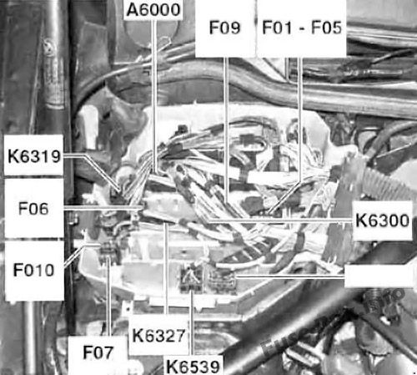
Turbo versions, before 03.2007
№ | A | Protected circuits
F01 | 30 | Ignition coils  Interference suppression capacitor
F02 | 30 | Coolant thermostat  Electric coolant pump  Exhaust camshaft sensor  Exhaust VANOS solenoid  Intake camshaft sensor  Intake VANOS solenoid
F03 | 20 | Crankshaft sensor  Engine control module (ECM)  Fuel tank vent valve  Mass air flow sensor  Oil condition sensor  Variable intake manifold controllers
F04 | 30 | Crankcase breather heater  Oxygen sensor heaters
F05 | 30 | Fuel injector relay
F06 | 10 | EAC sensor  E-box fan  Exhaust flap  Fuel tank leakage diagnostic module  Junction box  Secondary air injection mass airflow sensor
F07 | 40 | Valvetronic (WT) relay
F09 | 30 | Electric coolant pump
F010 | 5 | Crankcase breather heating relay
A6000 |  | Engine control module (ECM)
K6300 |  | DME main relay
K6319 |  | Valvetronic (WT) relay
K6327 |  | Fuel injector relay
K6539 |  | Crankcase breather heating relay

Turbo versions, since 03.2007
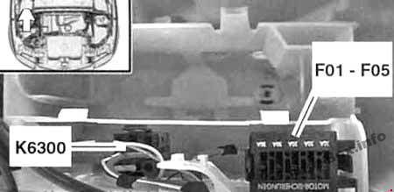
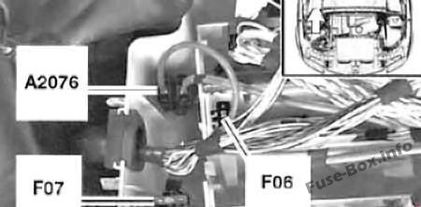
Turbo versions, since 03.2007
№ | A | Protected circuits
F01 | 30 | Ignition coils  Interference suppression capacitor
F02 | 30 | Coolant thermostat  Electric coolant pump  Engine control module (ECM)  Exhaust camshaft sensor  Exhaust VANOS solenoid  Intake camshaft sensor  Intake VANOS sensor  Wastegate valves
F03 | 20 | Crankshaft sensor  Fuel tank vent valve  Oil condition sensor  Volume control valve
F04 | 30 | Crankcase breather heaters  Oxygen sensor heaters
F05 | — | Not used
F06 | 10 | E-box fan  Exhaust flap  Fuel tank leakage diagnostic module
F07 | 40 | Electric coolant pump
K6300 |  | DME main relay
A2076 |  | B+ power

Non-turbo versions, before 03.2007
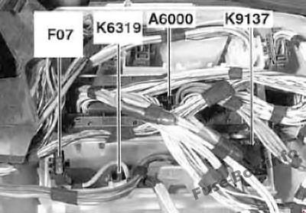
Non-turbo versions, before 03.2007
№ | A | Protected circuits
F07 | 40 | Valvetronic (WT) relay
A6000 |  | Engine control module (ECM)
K6319 |  | Valvetronic relay
K9137 |  | Electric cooling fan cutoff relay

Non-turbo versions, since 03.2007
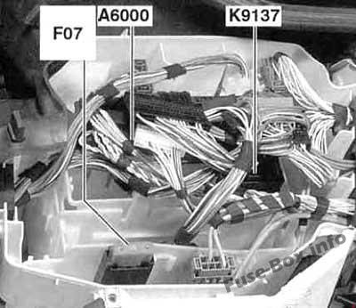
Non-turbo versions, since 03.2007
№ | A | Protected circuits
F07 | 50 | Electric coolant pump
A6000 |  | Engine control module (ECM)
K9137 |  | Electric cooling fan cutoff relay

Secondary air injection pump relay (2009-2010, non-turbo)
